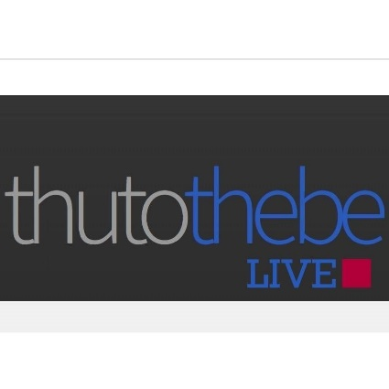

**Thutothebe Handbook**

**What is Thutothebe?**

Thutothebe embodies the ideology held by a group of individuals who have observed a gap in the education system of Botswana. The ideology seeks to tackle the root cause of most of Botswana’s socio-economic challenges: apparent insufficiency of information available to the Youth. Although this closely relates to politics, Thutothebe decides to enlighten the people. It is in its core beliefs that if the Youth actively seek knowledge, it will open their eyes to a pool of possibilities previously untapped.

It goes without saying that all the youth empowerment may not be as sustainable as previously enchanted to us. Nor is our leadership as strong and committed to us as required. Thutothebe understands that people are a product of their community and thus seeks to rectify this.

We aim to nurture a generation of voracious readers and critical thinkers. To create a globally competitive society that starves for helpful knowledge. This is all in hopes of addressing our most prominent socio-economic challenges.

**How does Thutothebe plan to address these?**

Thutothebe has amassed a legion of enthusiasts who share the same intention and are eager to perform their service to their community. Their plan of action includes but not limited to:

* Motivation speaking – A wise man once said, “motivation seeks to ignite a fire in your belly, to give you cause to rise against your circumstances”. Thutothebe intends to facilitate just that.
* Knowledge – If there is anything worse that being un-informed is being mis-informed, hence our mandate includes disseminating noteworthy information for public consumption, at no cost to you.
* Mentorship – Thutothebe ambassadors and contributors are normal people in extraordinary pursuits. It is their pleasure to take on young aspirants to help them navigate the complexities of starting up.
* Awards and Considerations – for special activities which are to be rolled out as time goes.

**What are the benefits/features that Thutothebe provides?**

Monthly newsletter – Read series of success stories, advice and steps to transform your life.

Online platforms – we have a high-end website loaded with sections for your informative enjoyment. Feast on small chunks of knowledge and relax to a breeze of visual arts, creative writing and more – you can have yours placed up there too.

We also host a quick response Facebook page, Twitter and Instagram. Follow us on your favorite platform and enjoy.



[www.thutothebelive.com](http://www.thutothebelive.com) FB, Twitter & Instagram: [@thutothebelive](http://www.instagram.com/thutothebelive)

Mentors: Get on a first name basis with some very accomplished Batswana, learn from them firsthand, network with some of the brightest minds in the country.

Special awards and considerations which will be sponsored annually.

**Who can be involved?**

Anyone interested can become a participant, there is a place for everyone.

_____________________________________________________________________________________

Forward all questions to: [e.nkgare@yahoo.com](mailto:e.nkgare@yahoo.com)

E. Nkgare; founder, coordinator